Why Android:

We have decided to develop our app in android for numerous reasons. The 3 options we had for developing were Windows, Apple IOS and Android. We decided against Windows because it is less popular and all 4 of us were not keen on developing in this especially when no one has a Windows phone.

Also when researching the popularity of all 3 platforms, Android was by far the most popular.

<http://www.bbc.co.uk/news/technology-29128083>

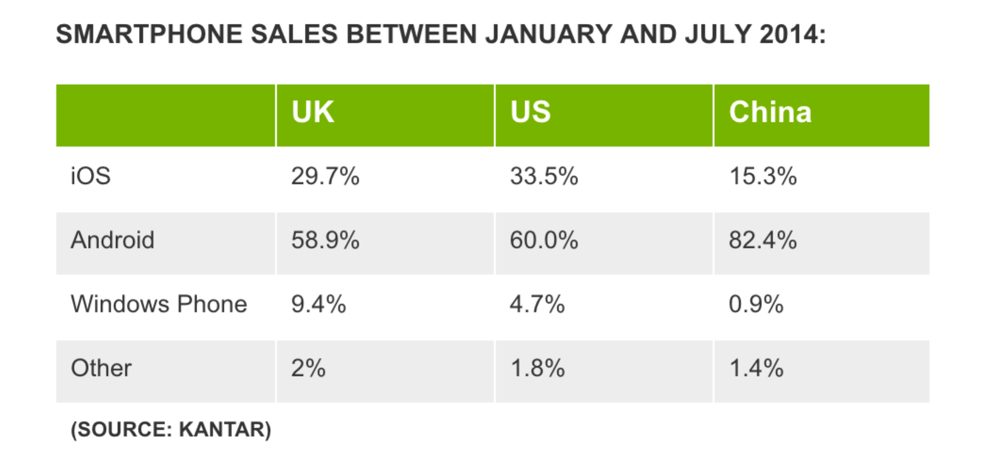

Also according to IDC- Analyze the future

<http://www.idc.com/prodserv/smartphone-os-market-share.jsp>

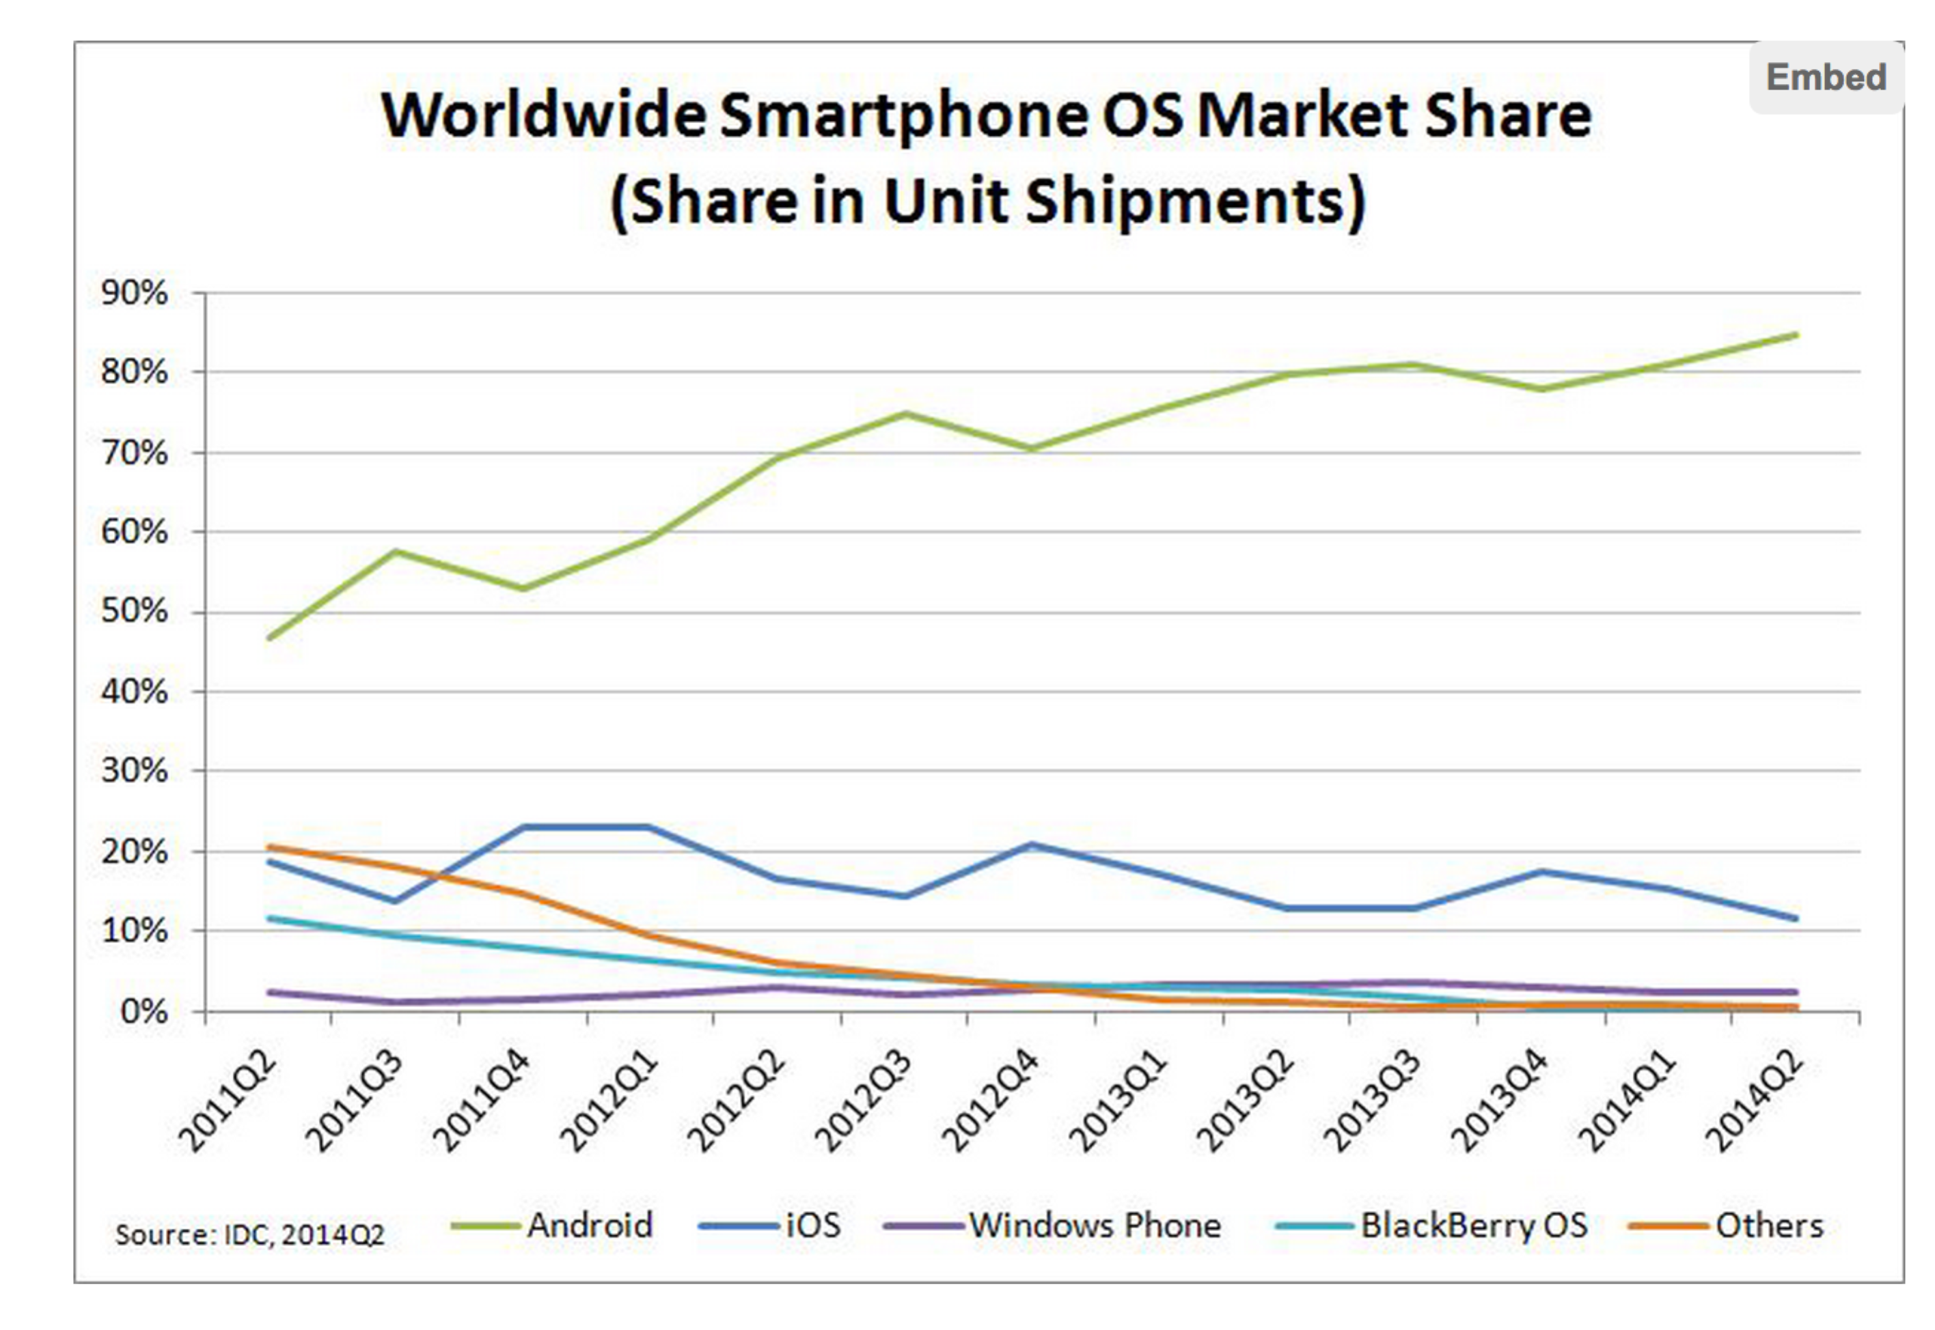

The reason we went against Apple IOS was because it was involve buying a developers license and learning a new language, which we thought would not be possible in the short time available. Therefore android was the obvious answer considering we all have previous Java experience and that it is open source.